Jenkins- Installation on Ubuntu 14.04 LTS
So, first of all, it is important to know that Jenkins is a web based application. To host it in your own system, you need to have a web-server installed-this may be either Tomcat, JBoss, Glassfish etc. My choice has always been Tomcat, so we would first go ahead and install Apache Tomcat on our system.
Installing Tomcat7
As of now, the current stable version of Apache Tomcat is Tomcat7. So without any further ado, we start with installing Tomcat7.
Open your terminal and type the following
$ sudo apt-get install tomcat7

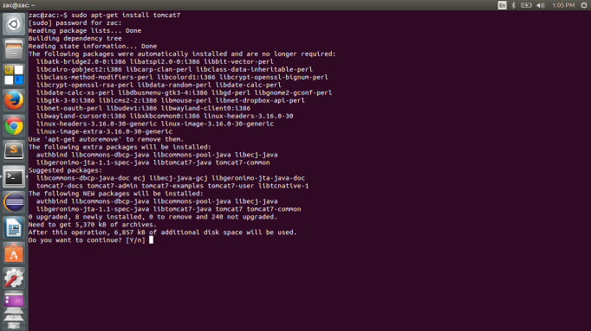

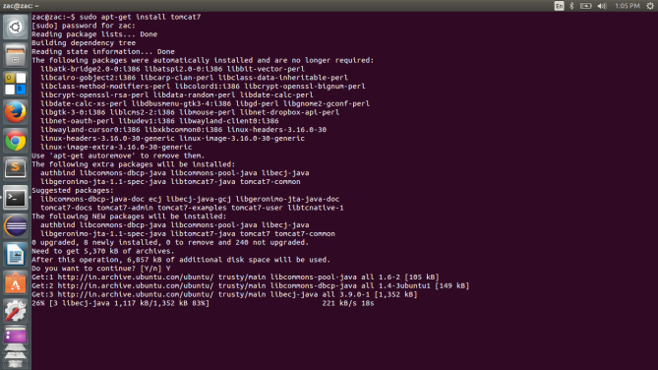

Once you are done with the installation of tomcat7, go to http://localhost:8080/ to make sure that tomcat7 is running properly.
Note : There are few paths that are of specific important –
- /var/lib/tomcat6 – These are the Java-y files for Tomcat. If you were to just extract Tomcat’s tar file and run it as a local user, these are the files you’d mostly be looking at.
- /usr/share/tomcat6 – These are the more Linux-y files for Tomcat. Tomcat’s binaries, shell scripts, bootstrap files, etc.
by default, tomcat7 listens to port no 8080. If you want to change this, you can do this by changing server.xml file in/var/lib/tomcat6/conf.

Now, we’re gonna good to install Jenkins.
Installing Jenkins
We need to have the following commands run for installing Jenkins. Before we can install Jenkins, we have to add the key and source list to apt. This is done in 2 steps, first we’ll add the key.

$ wget -q -O - https://jenkins-ci.org/debian/jenkins-ci.org.key | sudo apt-key add -
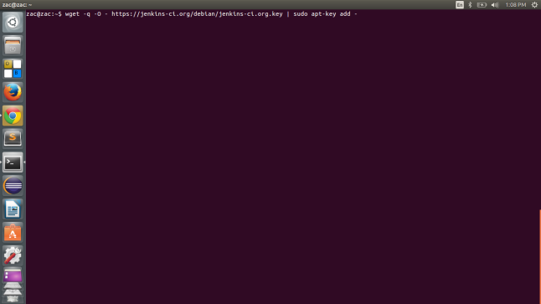

Now run this
$ sudo sh -c 'echo deb http://pkg.jenkins-ci.org/debian binary/ > /etc/apt/sources.list.d/jenkins.list'

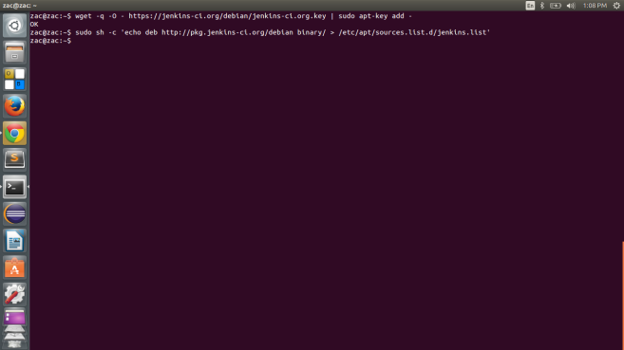

We have to then update apt’s cache before we can install Jenkins.
$ sudo apt-get update
Now install Jenkins with apt
$ sudo apt-get install jenkins

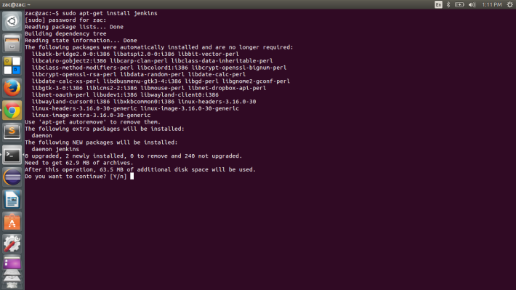

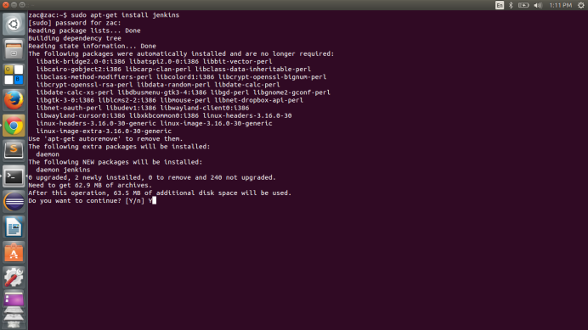

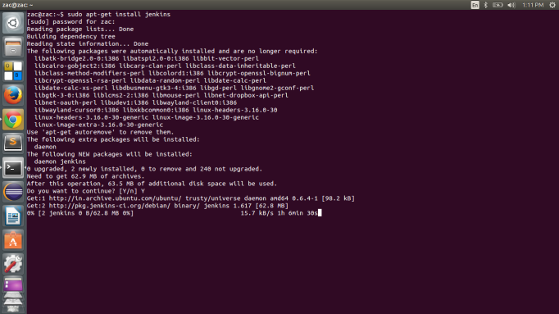

Now that you have Jenkins installed on your system, you are in a good position to run Jenkins, but, after a few modifications. Go to http://localhost:8080/jenkins. You need some more configurations.
Copy the jenkins.war file that you would have recieved after downloading Jenkins. Now you may wander, where is it. Run the whereis command to find where it is
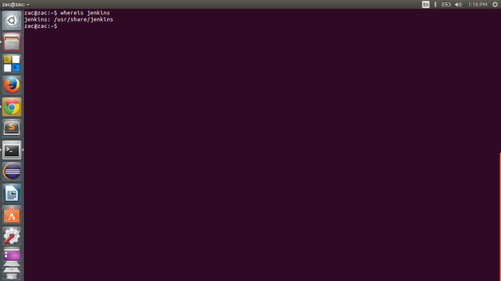

We find that it is in /usr/share/jenkins. It’s time to go to the corresponding folder and then locate the file.
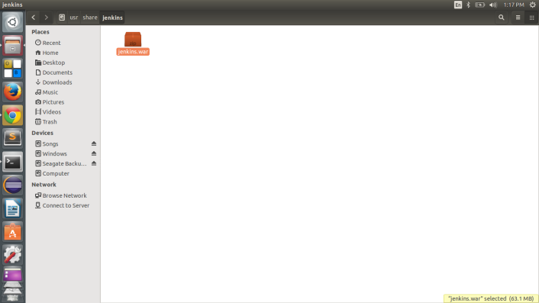
Now we need to copy this file to /var/lib/tomcat7/webapps. But there is a catch-
Ubuntu doesn’t allows simply copy pasting of any files or folders in this case, because these are system program files. So you need to have a workaround. We will use the gksudo command to get superuser access and then copy paste the files.
Now gksudo doesn’t comes pre-installed with Linux. So we go ahead and install it too. It is a very light file (~700 KBs).
Once we have it installed, we go ahead and run this command
$ gksudo nautilus
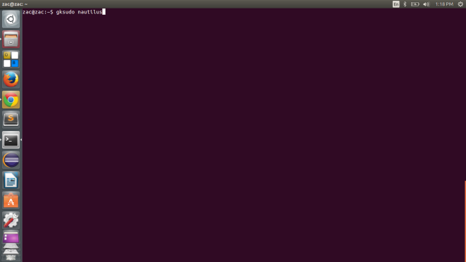
This will open the file browser in Superuser mode.
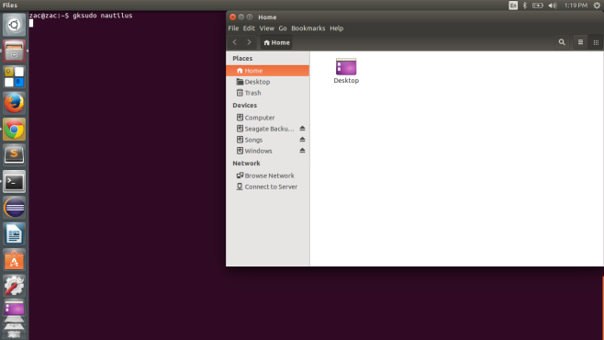
We copy the jenkins.war file from /usr/share/jenkins to /var/lib/tomcat7/webapps.
You’ll see a jenkins folder immediately gets created
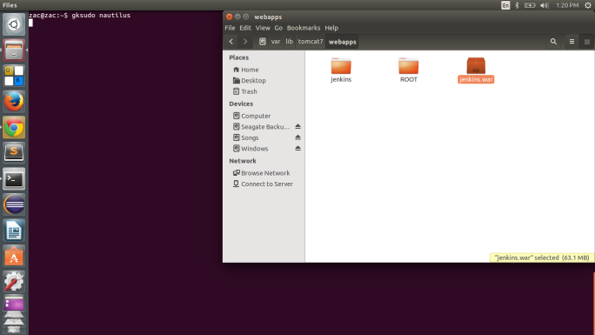

If you check http://localhost:8080/jenkins now, you’ll get your still get an error:
Unable to create the home directory '/usr/share/tomcat6/.jenkins'. This is most likely a permission problem.

To change the home directory, use JENKINS_HOME environment variable or set the JENKINS_HOME system property. See Container-specific documentation for more details of how to do this.

Now you will need to run these three commands
$ cd /usr/share/tomcat7
$ sudo mkdir .jenkins
$ sudo chown tomcat7:nogroup .jenkins
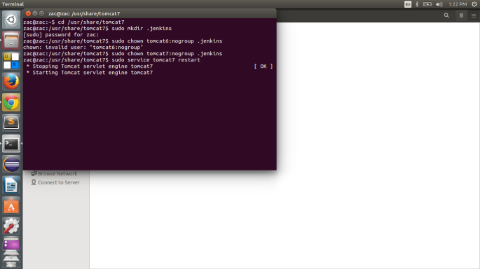

Now go ahead and re-start your tomcat7 server with this command
$ sudo service tomcat7 restart
Once tomcat7 restarts, go ahead and type this in browser http://localhost:8080/jenkins. You will see Jenkins start up. It will take some time at first
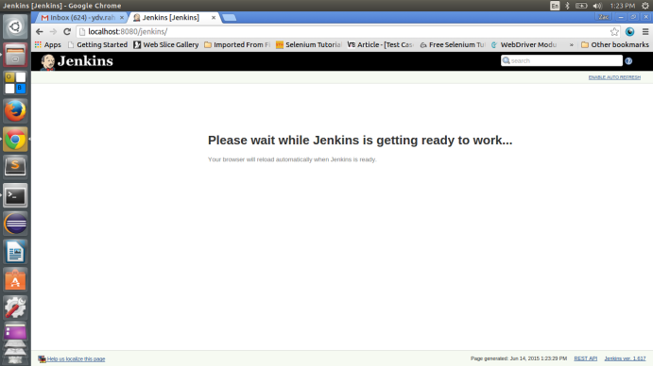

You’ll then see the Jenkins welcome home page
